Windows 10 /11: Delete and merge hard disk partitions

Once your hard disk is partitioned, you have the flexibility to delete the new partition(s) at any time and add it/them to another existing partition. However, any **data on the deleted partition will be lost** during this process! Ensure you back up any important files in advance.

Step 1: Open Disk Management

In the first step, as with the creation of new partitions, open Disk Management:

* use the key combination **[Windows] + [R]** and choose the command “**diskmgmt.msc**” or
* Right-click on the **Start menu icon** in the taskbar and select “**Disk Management**”.

Step 2: Select and delete partition

Find the hard disk partition you want to delete in the list of volumes or in the disk overview, and right-click on the entry. Then click “**Delete Volume**”.

[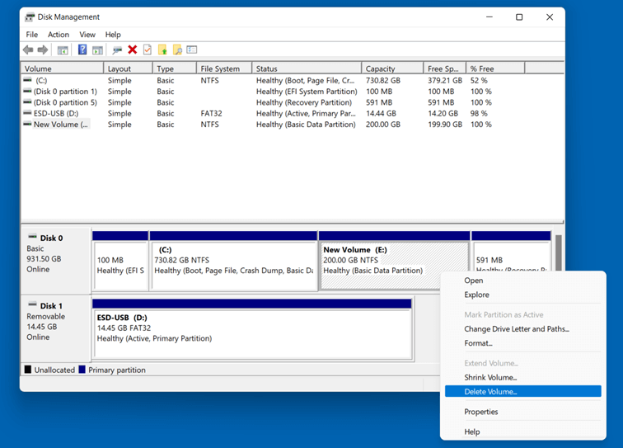](https://www.ionos.com/digitalguide/fileadmin/DigitalGuide/Screenshots_2022/win11_festplatte10_en.png)Delete volume in Windows 11 Disk Management

You will receive a message confirming you want to delete the data from the hard disk partition. Click on “**Yes**” to continue the process.

[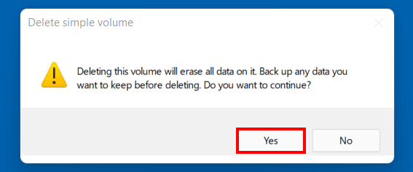](https://www.ionos.com/digitalguide/fileadmin/DigitalGuide/Screenshots_2022/win11_festplatte11_en.png)“Delete simple volume” dialog box in Windows 11

Step 3: Extend volume

After you have deleted a hard disk partition in Windows 11, the space of this partition will appear in the Disk Management with the label “**Unallocated**”. You can now assign the quota to another existing partition on the same hard drive by right-clicking the partition you would like to extend and clicking “**Extend Volume**”.

[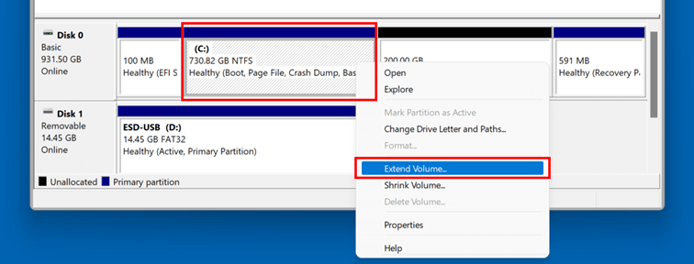](https://www.ionos.com/digitalguide/fileadmin/DigitalGuide/Screenshots_2022/win11_festplatte12_en.png)Partition Hard Disk: Extend Volume

In the wizard, click “**Next**” to begin. In the following overview, you will see **how much storage space is available for extending the partition** – in this case, the available storage corresponds to the 200 gigabytes that are “unallocated” after performing the previous step. Either accept the suggested maximum value or choose an individual value by adjusting the number beside “**Select the amount of space in MB**”.

[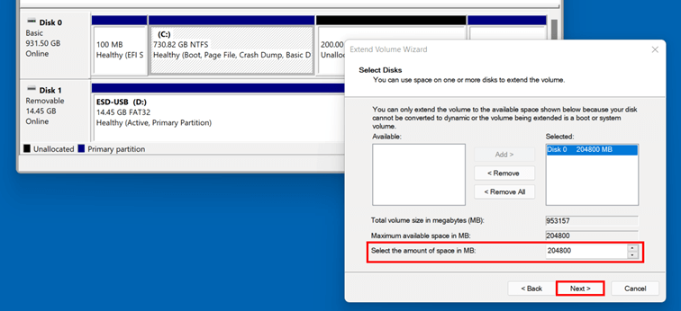](https://www.ionos.com/digitalguide/fileadmin/DigitalGuide/Screenshots_2022/win11_festplatte13_en.png)Windows 11: Volume Extension

Click **“Next**” and “**Finish**” when prompted to complete merging the partitions – which will be immediately available in the new form.